Ronan Keaveney S00198790 Website Project

Introduction

The website I made is based on a popular series called Vikings. It can be found on multiple streaming platforms and is widely known. The intended audience is for people who are thinking about watching the show and are just looking for more information and also people who have seen it before can come onto the site and look at recent updates that may be posted (In the latest news tab or videos page).

GitHub

<https://ronankeaveney.github.io/finishedwebsite/website/>

Website Described

Page 1 – This is just a simple information page explaining the websites purpose

Page 2 – This page summarises each season of the series

Page 3 – This page shows photos of the cast and shows their actors names

Page 4 – This page aims to show any new season trailers that are coming out or season highlights

HTML5 Validation Results

Page 1:

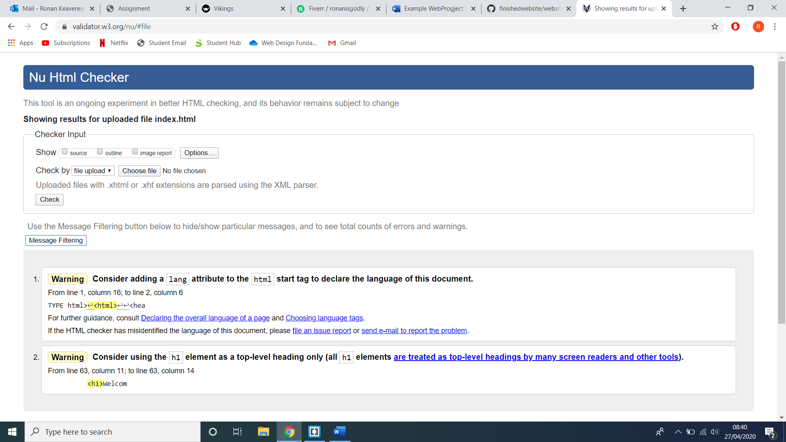

Page 2:

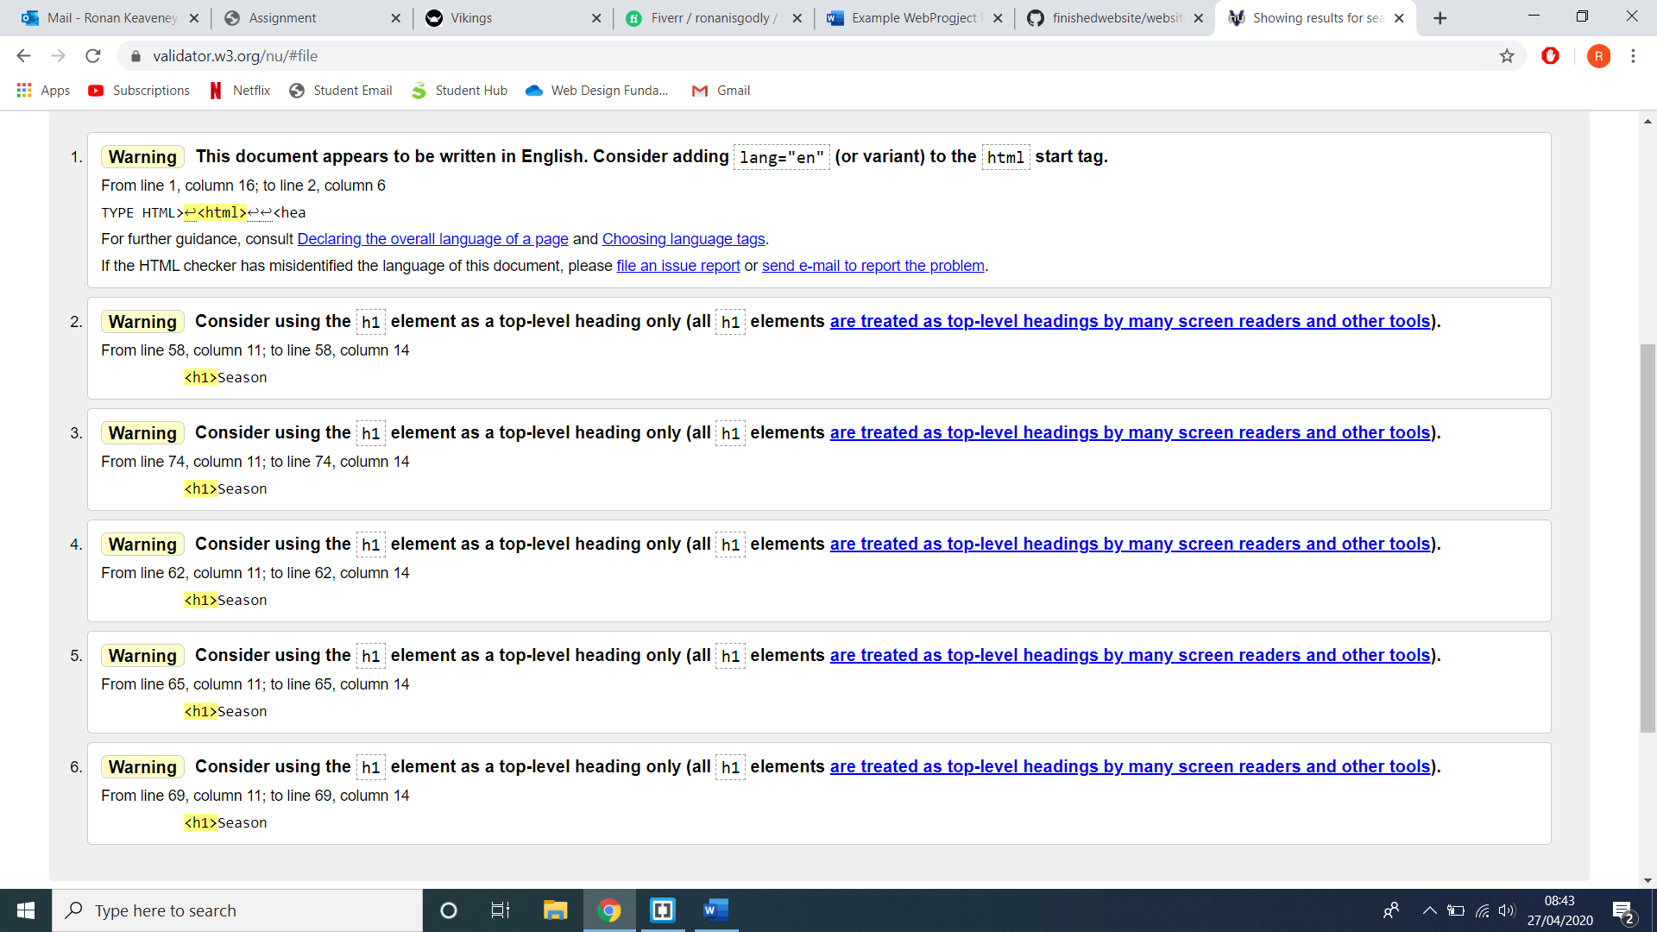

Page 3:

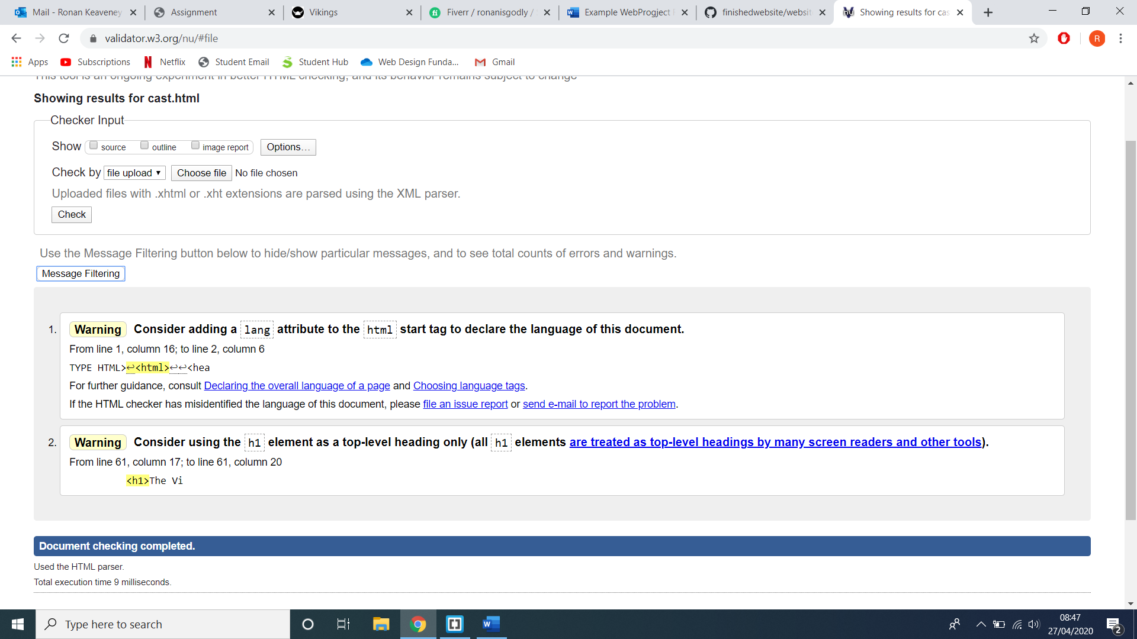

Page 4:

